DAA ASSIGNMENT-1
NANDANI RAUNIYAR
CH.SC.U4CSE24261

- Write a c program to find the sum of 1st n natural numbers using user-defined function.

CODE:
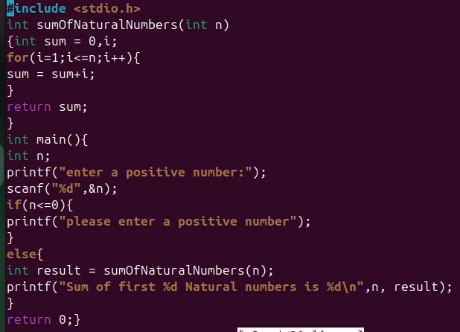

OUTPUT:
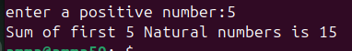

Time complexity: O(n)
Space complexity: O(1)
- Write a c program to find sum of squares of the 1st n natural numbers using user-defined function.

CODE:
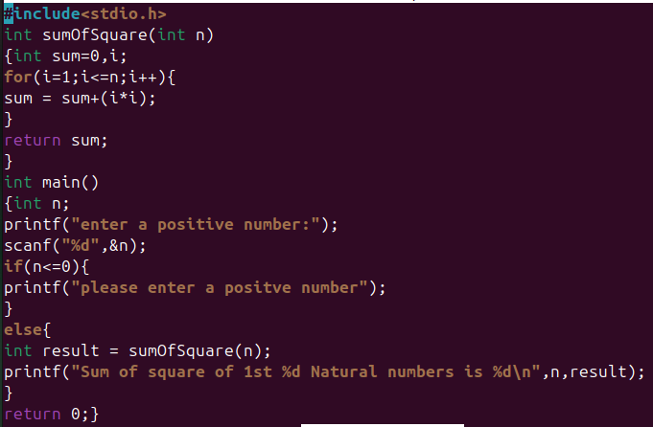

OUTPUT:
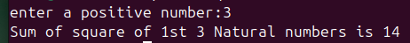

Time complexity: O(n)
Space complexity: O(1)
- Write a c program to find sum of cubes of the 1st n natural numbers.

CODE:
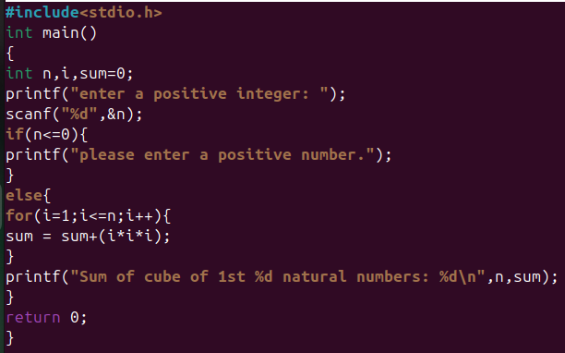

OUTPUT:
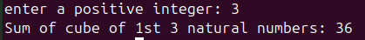

Time complexity: O(n)
Space complexity: O(1)

- Write a c program to find the factorial of natural number using recursive function.

CODE:
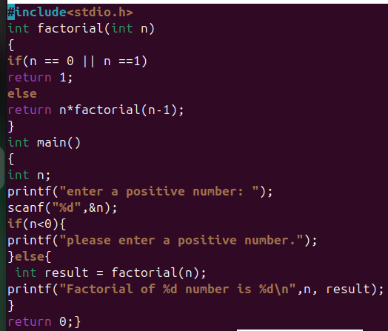

OUTPUT:
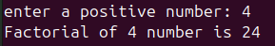

Time complexity: O(n)
Space complexity: O(n)

- Write a c program to transpose a 3x3 matrix.

CODE:
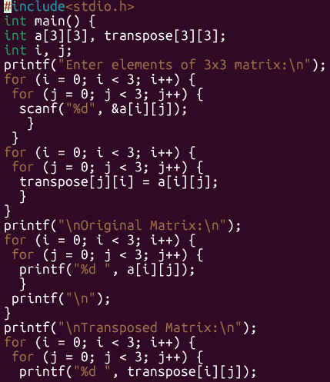
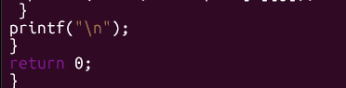

OUTPUT:
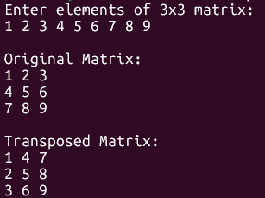
Time complexity: O(n²)
Space complexity: O(n²)

- Write a c program to print the Fibonacci series for 1st n natural numbers using user-defined function.

CODE:
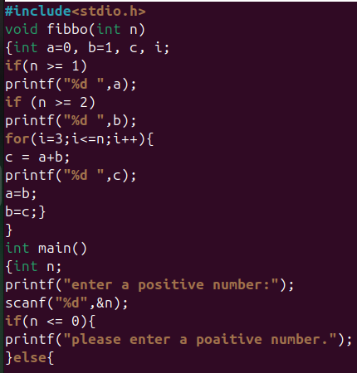
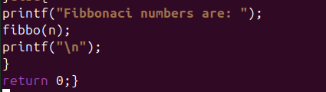

OUTPUT:
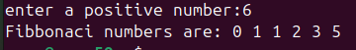

Time complexity: O(n)
Space complexity: O(1)

